Guide to Specializations

Video guide can be found here:
https://www.youtube.com/watch?v=zS0FXhHzTgE

Last Updated : Y2024 - M05 - D30

Specializations

Specializations (Specs) are akin to classes and unlock after reaching WT1 at lvl 30,
they each provide their specialization weapon and certain buffs and perks.

The three original specializations (Demo, Surv and Sharp) are unlocked by default, the other three (Tech, Gunner and Firewall) are unlocked by either owning the year 1 pass/ultimate, or by doing their field research.
For a guide to the field research you can reference this great guide by Hanakooh :
https://docs.google.com/document/d/1EzEKob8CQY3uU-ZWPS_PlimiyhaJTNEO7f9YjiqmQkg

Leveling Specializations

You also need to level each spec, this is done by earning points for that spec while it is equipped, these can come from :
- Leveling - 3 points per level up.
- Invaded missions - 5 points for the first weekly clear of each invaded mission.
- Daily bounties - 3 points points for normal and hard, 5 points for challenging, per completed bounty, they are the orange bounties.
- Projects - 3 points for daily project, 5 points for most weekly projects (it will state it in their rewards)
- Control points - 1 point for each control point 4 (Heroic) clear.
- Summit - 3 points for completing 10 and 20 challenges, 5 points for completing 30 challenges.

Items highlighted in green are the highly recommended parts.
Pistols are intentionally omitted, none of them are effective. Only the firewall sidearm is included.

Demolitionist
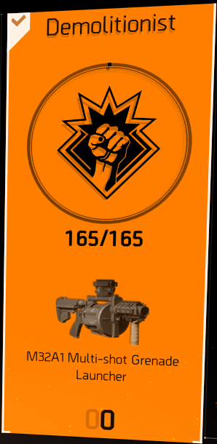 | Spec Weapon : M32A1 Multi-Shot Grenade Launcher.  Great anti group weapon, scales with explosive dmg stat.  Spec Grenade : Fragmentation grenade.  Medium radius, poor damage, applies bleed.  Spec Armour Kit :  Normal heal, 30 wep handling for 15 seconds.  Spec Skill : Mortar  Good group dmg skill, one of the best explosive skills.  Spec Attachment : 7 chc underbarrel laser  Great for an extra 2 chc, fits all rails.  Group Buff :  5 DTTOOC for other members of your subgroup.  Major Perks :  Ignore 1 Explosion and its damage per minute.  10% explosive damage.  Minor Perks :  On armour break, reloads main weapons.  20% Burn resistance.  Spec Ammo Counter :  Multiple kills with explosions adds 2 to the spec ammo bar.

Survivalist
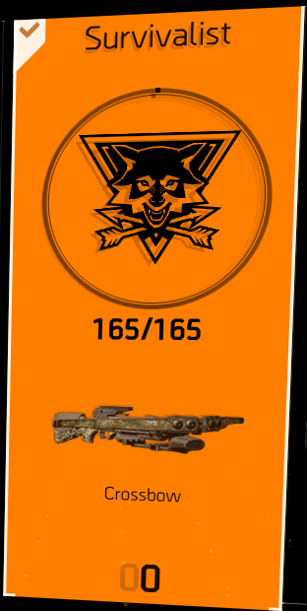 | Spec Weapon : Crossbow.  Great for breaking armour plates on heavies and warhounds, applies bleed, scales with explosive dmg.  Spec Grenade : Incendiary grenades.  Medium radius, lingering fire, great for sledge.  Spec Armour Kit :  Heals over 5 seconds, also heals allies within 20 meters.  Spec Skill : Mender Seeker  Mediocre healing skill, ok for red builds.  Spec Attachment : 5.56 mag  +30% optimal range, 100% useless.  Group Buff :  10% damage to status affected enemies for other members of your subgroup.  Major Perks :  10% protection from elites.  Minor Perks :  10% skill haste in cover.  15% outgoing healing.  Spec Ammo Counter :  Killing status affected enemies adds 3 to the spec ammo bar.

Sharpshooter
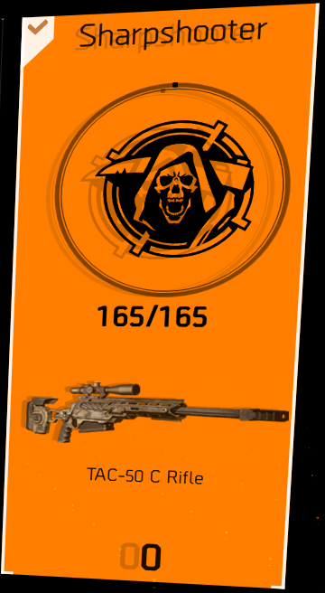 | Spec Weapon : TAC-50 C Rifle.  Great sniper tool, high dmg, scales with weapon dmg.  Spec Grenade : Flashbang grenade.  Large radius, almost no dmg, applies blind.  Spec Armour Kit :  Normal heal, removes status effects and gives bleed, poison and burn resist for 20 seconds.  Spec Skill : Tectician (Recon) Drone  Great vision tool, lingering spotting of an area.  Spec Attachment : Digital Scope  Good scope with dual zoom and clear reticule.  Group Buff :  10% HSD dmg for other members of your subgroup closer to the enemy than you.  Major Perks :  15% HSD with MMR and Rifles.  15% stability for all weapons.  After 20 seconds in cover receive 5 mmr and rifle ammo.  Minor Perks :  Bonus armour when in cover.  Spec Ammo Counter :  Headshot kills adds 1 to the spec ammo bar.
Technician
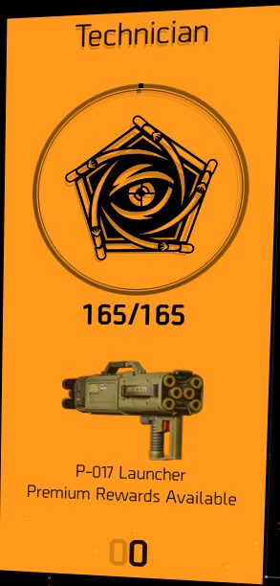 | Spec Weapon : P-017 Launcher.  Mediocre tool, ok for opening fights, scales with explosive dmg.  Spec Grenade : EMP grenade.  Large radius, great anti material tool, applies disrupt.  Spec Armour Kit :  Normal heal, also heals nearby skills.  Spec Skill : Artificer Hive  Great buff and heal for skills, including shields.  Spec Attachment : Linked Laser Pointer  Spots ADS’d enemies, great for flatline/HB.  Group Buff :  Faraday field on deployed skills, prevents shock and disrupt on allies within 5m of skill.  Major Perks :  +1 Skill tier.  Minor Perks :  10 skill damage/ 10 skill healing.  12% dmg vs mechanicals.  Spec Ammo Counter :  Destroying proxies or mechanicals adds 1 to the spec ammo bar.
Gunner
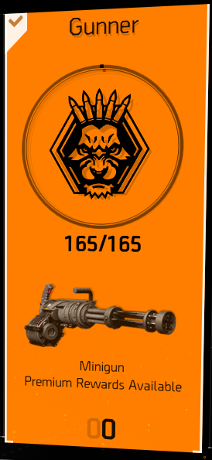 | Spec Weapon : Minigun.  Good dmg dealer, cannot run or use cover, scales with weapon dmg.  Spec Grenade : Riot Foam Grenade  Small radius, good cc, applies foam.  Spec Armour Kit :  Normal heal, 30% bonus armour for 10 seconds.  Spec Skill : Banshee Pulse  Great CC tool, easy to use. Has a charge up mechanic.  Spec Attachment : Large Pouch  +50 ammo for pouch based LMG’s.  Group Buff :  5% ammo reserves per 60 seconds (Both subgroups).  Major Perks :  10% Armour on kill  5% ROF on kill for 5 seconds.  Minor Perks :  10% ammo reserves per 60 seconds.  10% WH when standing still for longer than 1 second.  Every third reload is 50% faster.  Spec Ammo Counter :  Killing multiple enemies without releasing the trigger adds 1 to the spec ammo bar.
Firewall
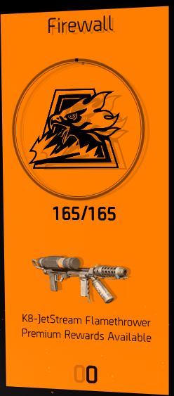 | Spec Weapon : KB-Jetstream Flamethrower.  Ok dmg weapon, good CC tool, scales with weapon dmg and Status.  Spec Grenade : Cluster Grenade  Multiple Small Radii, mediocre dmg.  Spec Armour Kit :  200% health and armour over 10 seconds.  Spec Skill : Striker Shield  Small shield, has damage buff for self and group, 11-12% per enemy depending on mods and tier.  Spec Attachment : 10CHD long rail underbarrel.  Only CHD mod on weapons worth using, requires a long underbarrel rail on the weapon.  Group Buff :  10% increased dmg to enemies within 10 meters of you for all allies (Both subgroups).  Major Perks :  30% health on kill  Burn enemies within 5m on armor break.  Minor Perks :  20% burn duration.  Spec Ammo Counter :  Killing enemies within 10 meters adds 1 to the spec ammo bar.  Specialization Pistol : Firestarter.  Allows for fire on normally immune enemies.

Group Spec Ammo Counter
The group special ammo bar is the bar consisting of 15 parts, it sits at the very left of the floating ammo ui. Every group wide kill adds in one pip, and each spec has an action that will add 1 or more pips whenever you do that action.
Once it is full the next kill will drop specialization ammo.
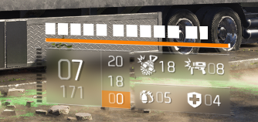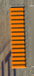
Certain specializations with certain builds can fill the bar very quickly, for example explosive builds and demo, fire eclipse and survivalist or close quarters builds and firewall.
This can also be important for the ‘hard to earn’ directive, as it will use the same bar for armour packs

General Tips
- For leveling specs up, equip any spec you still need points in, and do your projects and invaded missions with them, and do all of your daily bounties. as those give quick extra points while leveling up as well. And If you need more, do control points on heroic, as you also get levels and blueprints, or just focus on leveling for the 3 points per level up.
- Spend your points first on the weapontype you use, and then get any of the recommended items or perks.
- You can respec fully at any time, and there is also a button to just respec one single element.
- Boosting a character to wony will give full upgrade points to demo, surv and sharp.
- Specialization weapons only do 50% damage against named enemies, this was changed as everybody used to nuke the bosses with them, nowadays it is better to just not use them on named enemies. (named enemies include rogue agents from encounters)
- By not putting the points into the pistol element, or removing them from it, you can avoid or deconstruct the pistols and not have them clutter your inventory.

Links to my other guides, the Build Collection, DMG/DPS Calculators and many other things:

https://docs.google.com/document/d/15mg-_sjowh5_8bUp2VIBqnDxCDqz-xJOISl0DlG3RDU

